# ****Power BI Inflation Analysis: Journeying Through Global Economic Terrain****

# Team ID:PNT2025TMID06736

# Team Members:

E.Anand Babu(22FE5A0322)

J.Bhargav Sai(22FE5A0326)

I.Venkata Ravikumar(21FE1A0304)

G.Siva Nagendra Prasad(22FE5A0323)

**CONTENT**

1.INTRODUCTION

1.1 Project Overview

1.2 Purpose

2. IDEATION PHASE

2.1 Problem Statement

2.2 Empathy Map Canvas

2.3 Brainstorming

3. REQUIREMENT ANALYSIS

3.1 Customer Journey map

3.2 Solution Requirement

3.3 Data Flow Diagram

3.4 Technology Stack

4. PROJECT DESIGN

4.1 Problem Solution Fit

4.2 Proposed Solution

4.3 Solution Architecture

5. PROJECT PLANNING & SCHEDULING

5.1 Project Planning

6. FUNCTIONAL AND PERFORMANCE TESTING

6.1 Performance Testing

7. RESULTS

7.1 Output Screenshots

8. ADVANTAGES & DISADVANTAGES

9. CONCLUSION

10. FUTURE SCOPE

11. APPENDIX

Source Code(if any)

Dataset Link

GitHub & Project Demo Link

**INTRODUCTION**

### ****Project Overview****

### Inflation significantly impacts global economies, affecting businesses, consumers, and policymakers. The **Power BI Inflation Analysis** project aims to provide a comprehensive data-driven approach to analyzing inflation trends. This project integrates real-time and historical inflation data, applies predictive modeling, and delivers interactive dashboards to enable businesses and financial analysts to make informed decisions.

**1.2 Purpose**

The key objectives of this project include:

**Enhancing Data-Driven Decisions** – By integrating inflation data from multiple sources, businesses can optimize pricing strategies, mitigate risks, and improve investment outcomes.

**Improving Data Consistency** – Standardizing inflation reporting across various regions ensures accurate comparisons and enhances data reliability.

**Expanding Access to Historical Data** – Incorporating long-term trends helps users understand inflation patterns and develop strategic policies.

**Providing Actionable Insights** – Interactive dashboards visualize inflation trends to aid decision-making.

**Increasing Business Confidence** – Organizations can make strategic decisions backed by real-time data visualizations.

**Facilitating Macroeconomic Analysis** – Policymakers and economists can analyze inflation trends across different regions and predict future economic shifts.

**Supporting Financial Planning** – Investors and financial analysts can assess inflation’s impact on stock markets, interest rates, and purchasing power.

**Automating Inflation Reporting** – Reducing manual data processing by generating automated reports for governments, businesses, and research institutions.

**Encouraging Transparency in Economic Data** – Providing publicly accessible dashboards for better economic literacy and awareness.

These enhancements ensure that the Power BI Inflation Analysis project delivers **comprehensive, reliable, and actionable** insights to users across various sectors. 🚀

1. **IDEATION PHASE**
   1. **Problem Statement**

**Customer Problem Statement Template:**

I am a multinational corporation operating in diverse markets.  
I’m trying to make data-driven decisions to optimize pricing strategies, mitigate risks, and enhance investment outcomes.  
But I face challenges with inconsistent data integration, limited historical data availability, and complex economic interdependence.  
Because different regions report inflation data differently, historical data is scarce, and global economic factors influence each other unpredictably.  
Which makes me feel uncertain about making accurate predictions and strategic decisions that align with each market’s economic conditions.

**Example:**

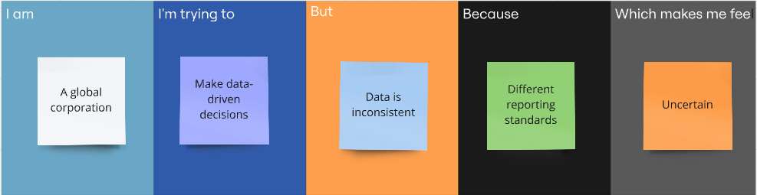

|  |  |  |  |  |  |
| --- | --- | --- | --- | --- | --- |
| **Problem Statement (PS)** | **I am (Customer)** | **I’m trying to** | **But** | **Because** | **Which makes me feel** |
| PS-1 | A multinational corporation operating in diverse global markets. | Use inflation data to make smart pricing and investment decisions. | The data is inconsistent and hard to analyze. | Different regions report inflation differently, and historical data is often missing. | Uncertain and less confident about decision-making. |
| PS-2 | A global retail corporation with operations in many countries. | Understand inflation trends to make pricing and supply chain decisions. | The data is inconsistent and hard to compare. | Each country reports inflation differently, and data is often incomplete. | Vulnerable to making bad decisions that could hurt profits. |

**2.2 Empathy Map Canvas**

**Empathy Map Canvas:**

An empathy map is a simple, easy-to-digest visual that captures insights about stakeholders’ perspectives on inflation impacts and economic challenges.

It is a useful tool that helps teams better understand how inflation dynamics affect business strategies and decision-making.  
Creating an effective inflation strategy requires understanding the real economic issues and the perspectives of those who are impacted. The exercise of creating the map helps participants consider inflation effects from the viewpoint of various stakeholders, including their goals, challenges, and responses to economic shifts.

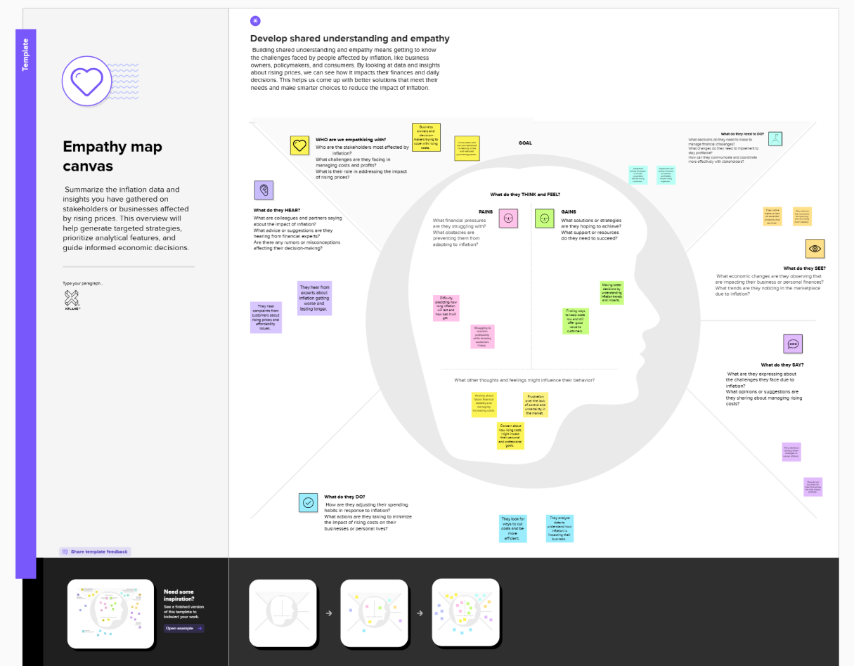

Reference:[click here to check more in detail](https://app.mural.co/t/dataanalysis1412/m/dataanalysis1412/1742572535512/1186656ffc5adb51df5180840b1a26eaf481a855)

* 1. **Brainstorming**

**Brainstorm & Idea Prioritization Template for Power BI Inflation Analysis:**

Brainstorming is an essential part of analyzing global inflation trends and developing data-driven insights for multinational corporations. This process encourages team members to share creative ideas and practical solutions, focusing on exploring diverse perspectives to tackle challenges related to data integration, historical data accessibility, and complex economic interdependencies.

By fostering an open and collaborative environment, team members can freely discuss potential approaches and share innovative techniques to improve data accuracy and visualization in Power BI dashboards. Out-of-the-box thinking is highly valued, as it helps uncover unique solutions that might otherwise be overlooked.

Reference:[click here](https://app.mural.co/t/dataanalysis1412/m/dataanalysis1412/1742492697379/a86bce032d9261efa19be1d0288acb62d65a09e8)

**Step-1: Team Gathering, Collaboration and Select the Problem Statement**

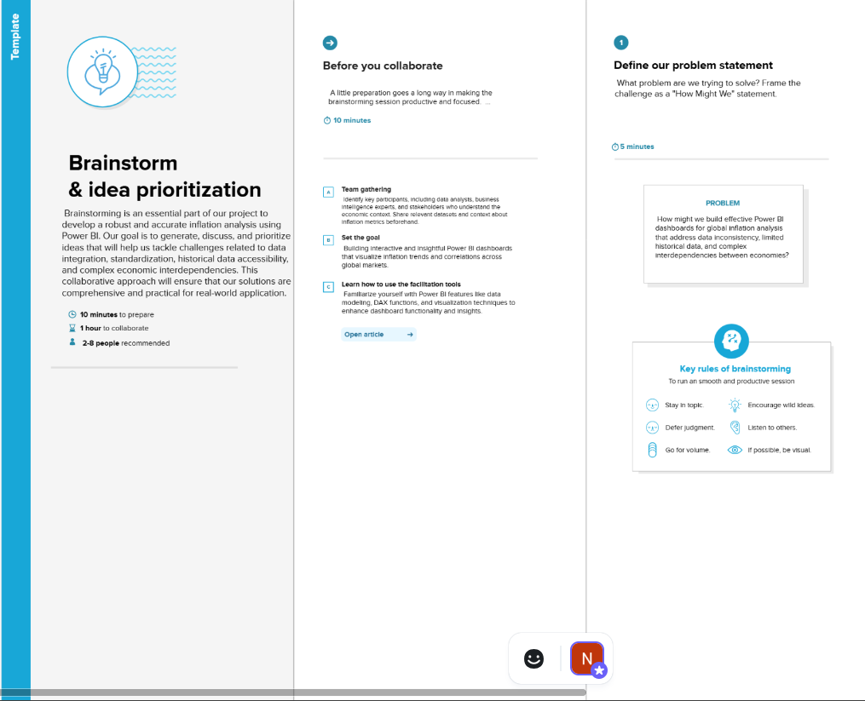

**Step-2: Brainstorm, Idea Listing and Grouping**

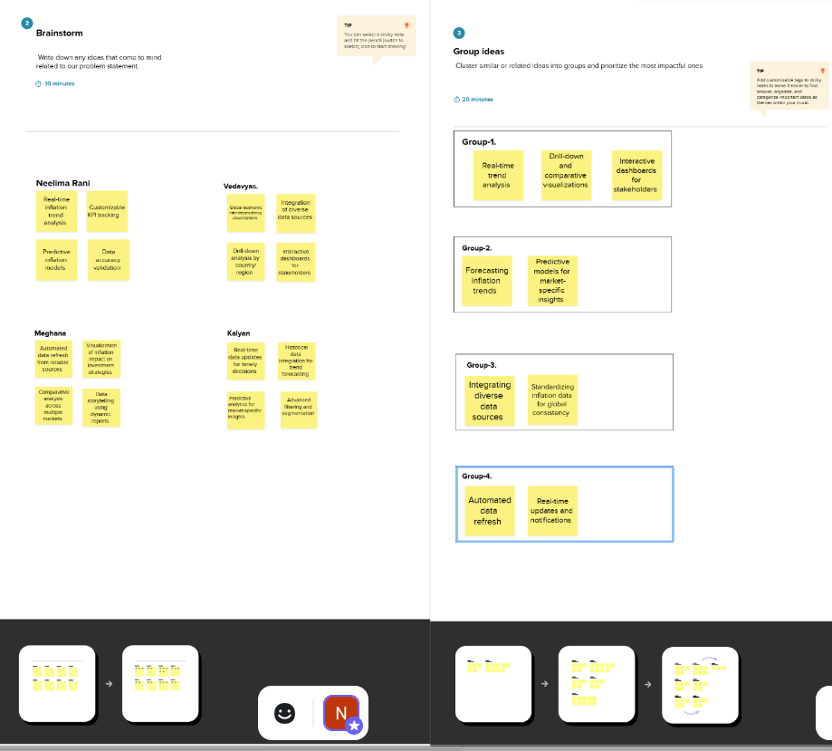

**Step-3: Idea Prioritization**

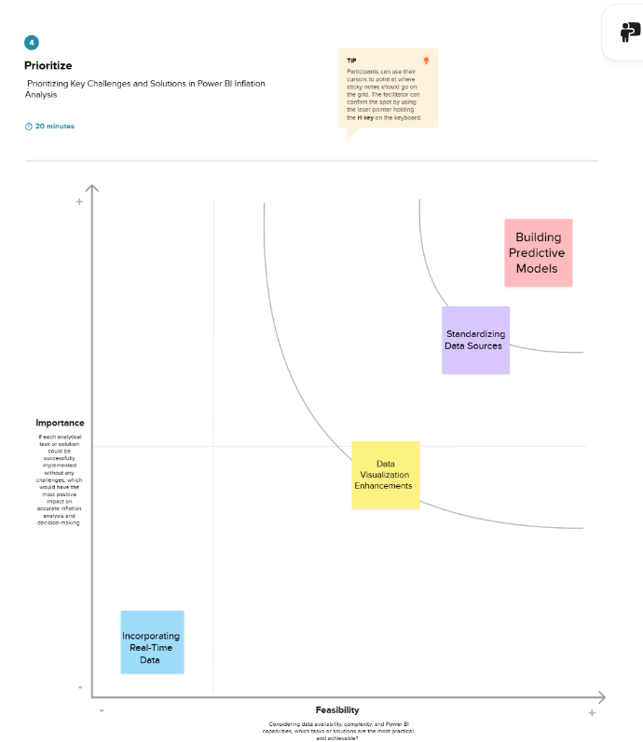

**3. REQUIREMENT ANALYSIS**

**3.1 Customer Journey map**

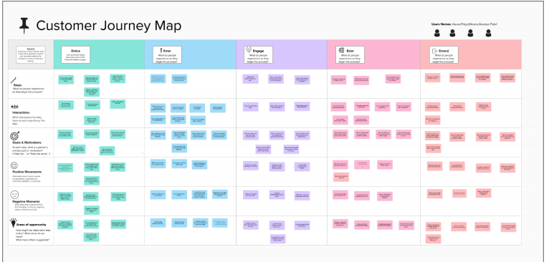

Reference::[Click Here](https://app.mural.co/t/neelima8405/m/neelima8405/1742801093808/bab2e9330b0cd3287b7aba0cd0dbeb02155847c0)

**3.2 Solution Requirement**

**Functional Requirements:**

Following are the functional requirements of the proposed solution.

|  |  |  |
| --- | --- | --- |
| **FR No.** | **Functional Requirement (Epic)** | **Sub Requirement (Story / Sub-Task)** |
| FR-1 | Data Collection | Collect inflation data from multiple reliable sources  Automate data import from APIs and databases  Gather historical data for trend analysis |
| FR-2 | Data Standardization | Convert data formats to ensure uniformity  Handle missing or inconsistent data |
| FR-3 | Data Visualization | Build interactive dashboards to display inflation trends  Use Power BI visual elements (charts, graphs, heatmaps) |
| FR-4 | Data Reporting | Generate automated reports summarizing inflation insights  Include predictive analytics for future trends |

**Non-functional Requirements:**

Following are the non-functional requirements of the proposed solution.

|  |  |  |
| --- | --- | --- |
| **FR No.** | **Non-Functional Requirement** | **Description** |
| NFR-1 | **Usability** | The dashboard should have an intuitive and user-friendly interface for effortless navigation and data exploration. |
| NFR-2 | **Security** | Ensure secure access with role-based authentication and data encryption to protect sensitive information. |
| NFR-3 | **Reliability** | The system should provide accurate and consistent results without unexpected failures or data loss. |
| NFR-4 | **Performance** | The dashboards should load and update data efficiently, even with large datasets, to maintain responsiveness. |
| NFR-5 | **Availability** | The system should be available 24/7 to allow users to access real-time insights at any given time. |
| NFR-6 | **Scalability** | The solution should be able to handle increasing data volume and additional features without performance degradation. |

**3.3 Data Flow Diagram**

**Data Flow Diagrams:**

A Data Flow Diagram (DFD) is a traditional visual representation of the information flows within a data analysis system. In the context of our Power BI Inflation Analysis project, a neat and clear DFD can graphically depict the flow of inflation data, from data collection and preprocessing to visualization and report generation. It shows how inflation data is gathered from various sources, processed, analyzed, and transformed into interactive dashboards, providing valuable insights for strategic decision-making.

**Example of Data Flow Diagram:**

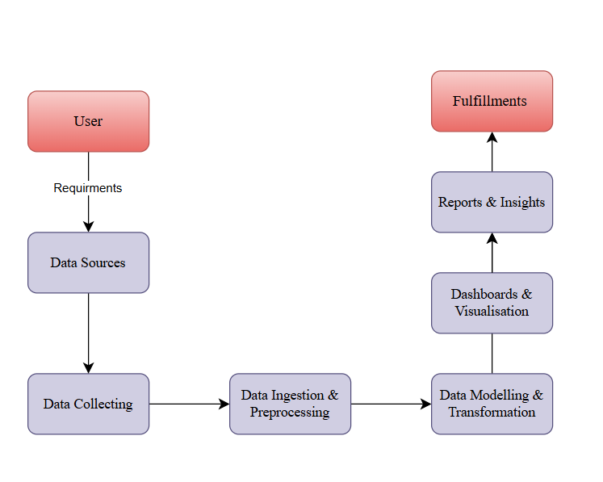

**User Stories**

Use the below template to list all the user stories for the product.

| **User Type** | **Functional Requirement (Epic)** | **User Story Number** | **User Story / Task** | **Acceptance criteria** | **Priority** | **Release** |
| --- | --- | --- | --- | --- | --- | --- |
| Data Analyst | Data Collection | USN-1 | .As a data analyst, I can collect inflation data from various sources to ensure comprehensive analysis. | I can access complete and accurate inflation data. | High | Sprint-1 |
|  | Data Standardization | USN-2 | As a data analyst, I will receive standardized data that is consistent across different sources | I can work with uniform data for reliable analysis. | High | Sprint-1 |
|  | Data Visualization | USN-3 | As a data analyst, I can visualize inflation trends using interactive dashboards. | I can view clear and insightful visualizations of inflation data. | Medium | Sprint-2 |
|  | Data Reporting | USN-4 | As a data analyst, I can generate comprehensive reports on inflation trends and predictions.l | I can produce reports that summarize key findings and insights. | Medium | Sprint-1 |
| Business User | Dashboard Access | USN-5 | As a business user, I can log into the dashboard to view inflation analysis and insights. | I can easily navigate and interact with the dashboard. | High | Sprint-1 |

**3.4 Technology Stack**

**Technical Architecture:**

The Deliverable shall include the architectural diagram as below and the information as per the table1 & table 2

### Example: ****Inflation Data Analysis Workflow in Power BI****

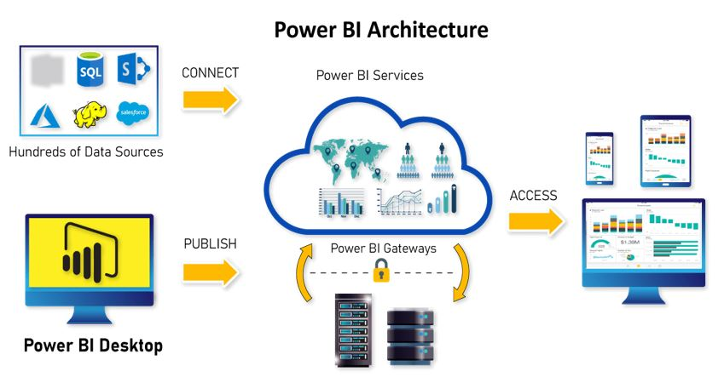

|  |  |  |  |
| --- | --- | --- | --- |
| **S.No** | **Component** | **Description** | **Technology** |
|  | User Interface | How users interact with the dashboards and reports. | Power BI Desktop, Power BI Service |
|  | Data Sources | Data input for analysis. | Excel, SQL, CSV, JSON |
|  | Data Transformation | Data cleaning, shaping, and transformation. | Power Query, DAX |
|  | Data Modeling | Establishing relationships between tables. | Power BI Data Model |
|  | Visualization Layer | Displaying data through charts and visuals.. | Power BI Visualizations, Custom Visuals |
|  | Cloud Service | Publishing and sharing reports online. | Power BI Service, OneDrive |
|  | File Storage | Storing project files and datasets. | Local Filesystem, OneDrive |
|  | External API-1 | API used for fetching real-time inflation data. | Inflation Rate API (e.g., FRED API) |
|  | External API-2 | API for currency exchange rates. | Exchange Rate API |
|  | Machine Learning Model | Model for predictive inflation trends. | Azure AutoML, Python Integration |
|  | Infrastructure (Server / Cloud) | Deployment and hosting platform. | Microsoft Azure, Cloud Storage |

**Table-2: Application Characteristics:**

| **S.No** | **Characteristics** | **Description** | **Technology** |
| --- | --- | --- | --- |
|  | Open-Source Frameworks | Frameworks used for data processing. | Python (Pandas, NumPy), R |
|  | Security Implementations | Data encryption and access control. | Row-level security (RLS), IAM |
|  | Scalable Architecture | Ensuring Scalability with larger data sets. | Power BI Premium, Azure Synapse |
|  | Availability | Ensuring availability of reports and dashboards. | Power BI Service with Auto-refresh |
|  | Performance | Optimizing performance with caching and tuning. | Power BI Aggregations, Dataflows |

**4.PROJECT DESIGN**

**4.1 Problem Solution Fit**

**Problem – Solution Fit Template:**

The Problem-Solution Fit ensures that the solution effectively addresses the customer’s problem. It helps business analysts, data professionals, and corporate decision-makers identify behavioral patterns and understand the effectiveness of their solutions.

**Purpose:**

* Enable data-driven decisions to optimize pricing strategies, mitigate risks, and enhance investment outcomes.
* Improve consistency in data integration and expand access to historical data
* Provide actionable insights to address the challenges of complex economic interdependence
* Standardize regional inflation data reporting to enhance accuracy and comparability.
* Increase business confidence by supporting strategic decisions with comprehensive ,real-time data visualization.

**Template:**

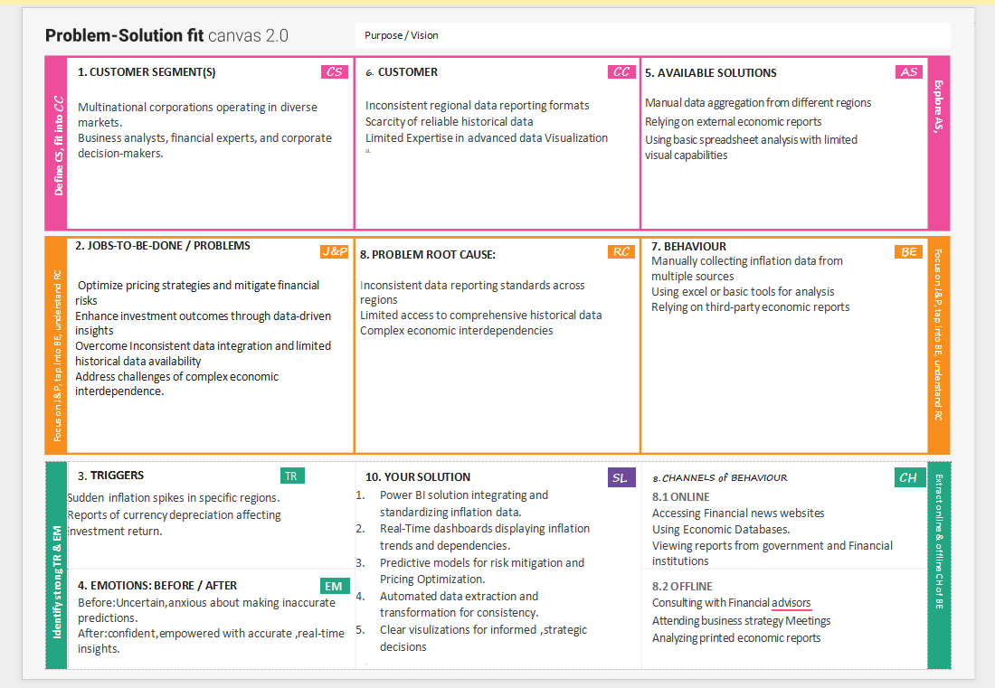

**4.2 Proposed Solution**

Project team shall fill the following information in the proposed solution template.

|  |  |  |
| --- | --- | --- |
| **S.No.** | **Parameter** | **Description** |
|  | Problem Statement (Problem to be solved) | The Corporation struggles with inconsistent data integration ,limited historical data ,and complex economic interdependence,making data-driven decisions challenging |
|  | Idea / Solution description | Develop a power BI solution to integrate and standardize inflation data,visualize trends and enhance predictive insights for strategic decision-making |
|  | Novelty / Uniqueness | Combines real time dashboards,automated data extraction,and predictive modeling to create dynamic and insightful visualizations |
|  | Social Impact / Customer Satisfaction | Enables better pricing strategies,risk mitigation,and investment decisions,leading to improved market adaptability and customer satisfaction |
|  | Business Model (Revenue Model) | Leverages data analytics as service model to offer insights and decision-making tools,enhancing profitability through data-driven strategies |
|  | Scalability of the Solution | The solution is scalable to include additional economic indicators,global regions ,and custom metrics,supporting future business expansion |

**4.3Solution Architecture:**

Solution architecture is a complex process – with many sub-processes – that bridges the gap between business problems and technology solutions. Its goals are to:

✅ Find the best tech solution to solve existing business problems.  
✅ Describe the structure, characteristics, behavior, and other aspects of the Power BI solution to project stakeholders.  
✅ Define features, development phases, and solution requirements.  
✅ Provide specifications according to which the solution is defined, managed, and delivered.

**Solution Architecture Diagram:**

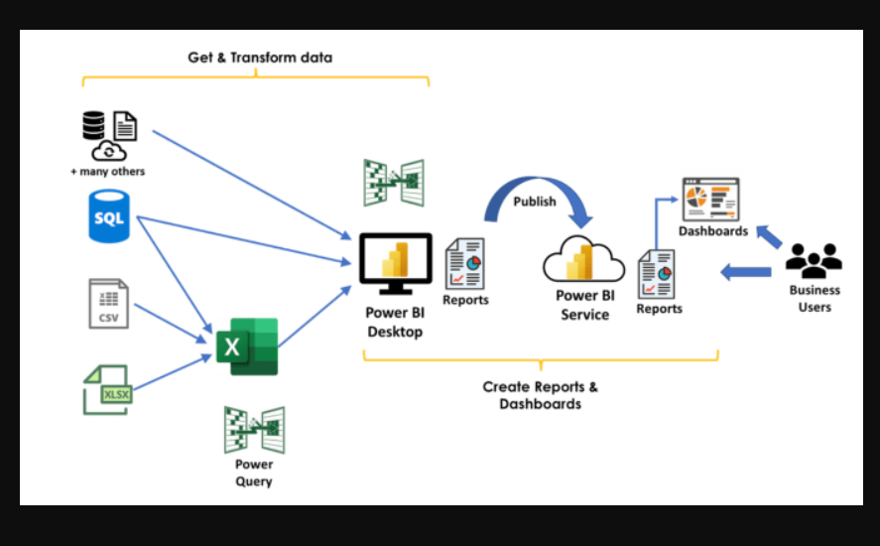

Architecture and Data Flow of the Power BI Inflation Analysis project

**5.PROJECT PLANNING & SCHEDULING**

**5.1 Project Planning**

**Project Planning Template (Product Backlog, Sprint Planning, Stories, Story points)**

template to create product backlog and sprint schedule

| **Sprint** | **Functional Requirement (Epic)** | **User Story Number** | **User Story / Task** | **Story Points** | **Priority** | **Team Members** |
| --- | --- | --- | --- | --- | --- | --- |
| Sprint-1 | Data Collection | USN-1 | As a User,I can collect inflation data from various sources | 2 | High | Team Members 1,2 |
| Sprint-1 | Data Preprocessing | USN-2 | As a user , I can clean and standardize data for accurate analysis. | 1 | High | Team Members 3,4 |
| Sprint-1 | Data Integration | USN-3 | As a user, ,I can Integrate datasets from multtiple sources into Power Bi. | 2 | Low | Team Members 4,1 |
| Sprint-2 | Data Visualization | USN-4 | As a user, I can view inflation trends on interactive Power Bi dashboards | 2 | Medium | Team Members 2,3 |
| Sprint-2 | Predictive Modeling | USN-5 | As a user, I can apply Forecasting models to predict inflation trends. | 1 | High | Team Members 3,4 |
| Sprint-2 | Dashboard | USN-6 | As a user,I can generate reports summarizing inflation insights | 3 | High | Team Members 4,1 |

**Project Tracker, Velocity & Burndown Chart: (4 Marks)**

| **Sprint** | **Total Story Points** | **Duration** | **Sprint Start Date** | **Sprint End Date (Planned)** | **Story Points Completed (as on Planned End Date)** | **Sprint Release Date (Actual)** |
| --- | --- | --- | --- | --- | --- | --- |
| Sprint-1 | 30 | 14 Days | 31 Jan 2025 | 13 Feb 2025 | 30 | 13 Feb 2025 |
| Sprint-2 | 30 | 14 Days | 14 Feb 2025 | 28 Feb 2025 | 30 | 28 Feb 2025 |

**Velocity:**

Imagine we have a 10-day sprint duration, and the velocity of the team is 20 (points per sprint). Let’s calculate the team’s average velocity (AV) per iteration unit (story points per day

**AV=Total Story Points /Sprint Duration= 30/14 =2.14**

**Burndown Chart:**

A burn down chart is a graphical representation of work left to do versus time. It is often used in agile[software development](https://www.visual-paradigm.com/scrum/what-is-agile-software-development/) methodologies such as [Scrum](https://www.visual-paradigm.com/scrum/scrum-in-3-minutes/). However, burn down charts can be applied to any project containing measurable progress over time.

**6. FUNCTIONAL AND PERFORMANCE TESTING**

**6.1 Performance Testing**

**Model Performance Testing:**

Project team shall fill the following information in model performance testing template.

|  |  |  |
| --- | --- | --- |
| **S.No.** | **Parameter** | **Screenshot / Values** |
|  | Data Rendered |  |
|  | Data Preprocessing |  |
| 3. | Utilization of Data Filters |  |
| 4. | DAX Queries Used |  |
| 5. | Dashboard design |  |
| 6 | Report Design |  |

**7. RESULTS**

**7.1 Output Screenshots**

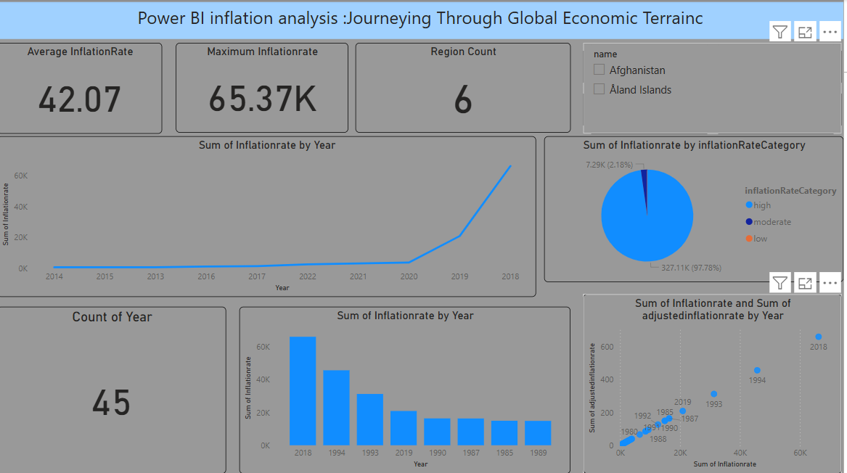

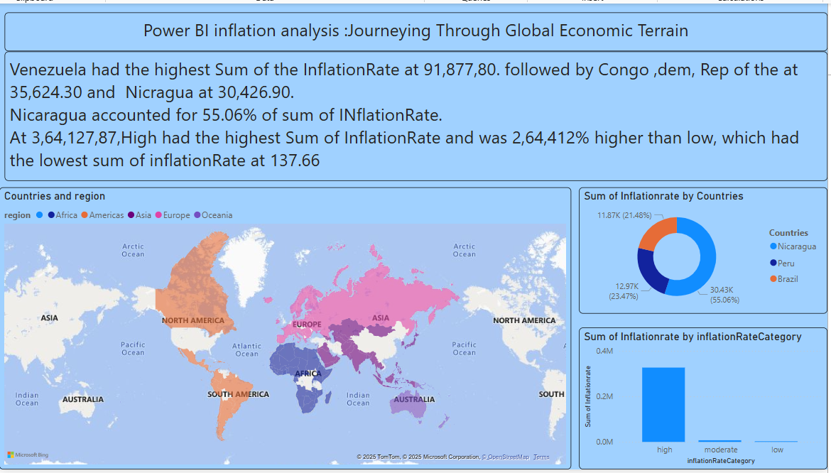

### 8. ADVANTAGES

Provides a user-friendly interface for seamless content sharing.

Enhances engagement through interactive features.

Offers data analytics to track performance and audience behavior.

### DISADVANTAGES

Requires significant infrastructure and maintenance costs.

Faces competition from well-established platforms.

Potential privacy and security concerns for users.

### ****9. CONCLUSION****

The platform aims to bridge gaps in existing video-sharing services.

Offers unique features tailored for a specific audience.

Provides opportunities for creators and users to engage effectively.

Focuses on user experience to stand out from competitors.

Aims to implement strong security and data protection measures.

Scalability potential to expand features based on user demand.

### ****10. FUTURE SCOPE****

Integration of AI-driven content recommendations.

Expansion to support multiple languages and regional content.

Enhancement of security measures for user data protection.

Development of interactive and immersive content formats (e.g., AR/VR).

Implementation of blockchain technology for copyright protection.

Improved monetization options for creators, including tipping and premium content.

Collaboration with influencers and brands to increase platform reach.

### ****11. APPENDIX****

Technical specifications of the platform.

Survey results and user feedback.

References and additional resources.

Comparison with existing video-sharing platforms.

Case studies of successful content creators.

Details on backend architecture and technology stack.